Deployment Steps for LGOSS TC:

Note: Make sure the domain is not running.

1. Change the package structure for the LGOSSAsyncReply Protocol

Copy the LGOSSAsyncReply protocol under src/com/sigma/samp/imp/{implName}/jeaProtocols in your repository

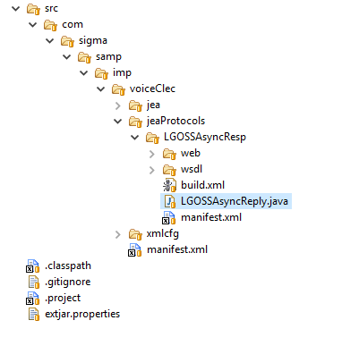

Update the LGOSSAsyncReply.java package structure change voiceClec to your implementation name.

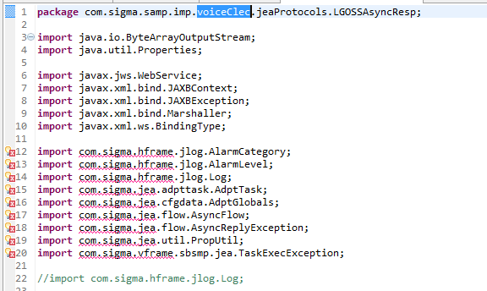

Run the build.xml and then follow the step 2

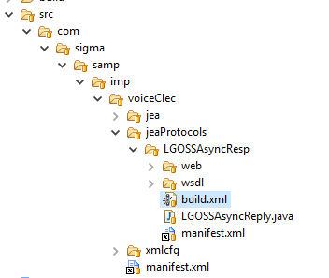

1. Copy the compiled **LGOSSreply.war** under dist/webapp folder.
2. Add JEA manifest on below locations:

dist/cfg/com/sigma/samp/imp/@implName@/jea

<Domain_Home>/cfg/com/sigma/samp/imp/@implName@/jea

@implName@ – will be the name of your implementation.

On this location copy the sbjealgoss folder which contains manifest of the JEA.

**Note: Update the manifest path according to your project, in our case it is voiceClec.

Below is the location in manifest which needs to be updated

<manifest name="com.sigma.samp.imp.@implName@.jea.sbjealgoss" type="JeaSpec" xmlns="http://www.sigma-systems.com/schemas/4.0/manifest" xmlns:dist="http://www.sigma-systems.com/schemas/4.0/distribution" xmlns:xsi="http://www.w3.org/2001/XMLSchema-instance" xsi:schemaLocation="http://www.sigma-systems.com/schemas/4.0/manifest com/sigma/samp/xmlcfg/schemas/manifest.xsd">

1. Copy the tech_cartridge **lgoss** to

dist/cfg/com/sigma/samp/imp/@implName@/xmlcfg/tech_cartridge folder

<Domain_Home>/cfg/com/sigma/samp/imp/@implName@/xmlcfg/tech_cartridge folder

1. Make entry of the tech_cartridge in smp_cfg.xml which is on the below location:

dist/cfg/com/sigma/samp/imp/@implName@/xmlcfg

<Domain_Home>/cfg/com/sigma/samp/imp/@implName@/xmlcfg

Entry to be made: **<xi:include href="tech_cartridge/lgoss/lgoss.xml"/>**

1. Copy the distribution jea **sbjealgoss.xml** on below location:

dist/cfg/com/sigma/samp/imp/@implName@/xmlcfg/distribution/jea

<Domain_Home>/cfg/com/sigma/samp/imp/@implName@/xmlcfg/distribution/jea

1. Copy the installation jea sbjealgoss.xml on below location:

dist/cfg/com/sigma/samp/imp/@implName@/xmlcfg/installation/jea

<Domain_Home>/cfg/com/sigma/samp/imp/@implName@/xmlcfg/installation/jea

Change the **soap_endpoint_uri** in this file .

*<dicommon:initParam name="soap_endpoint_uri" required="false" type="string">*

*<dicommon:description><![CDATA[End point URI for soap request to send]]></dicommon:description>*

*<dicommon:value><![CDATA[http://10.100.160.211:8181]]></dicommon:value>*

*</dicommon:initParam>*

1. Go to the distribution.xml which is on location :

dist/cfg/com/sigma/samp/imp/@implName@/xmlcfg

<Domain_Home>/cfg/com/sigma/samp/imp/@implName@/xmlcfg

Make the below entries in the **distribution.xml:**

1. Under resources 🡪 jmsDestinations add the below entries

*<jmsDestination jndiName="com.sigma.jms.queue.jea.sbjealgoss.backup" name="com.sigma.jms.queue.jea.sbjealgoss.backup" type="queue"/>*

*<jmsDestination jndiName="com.sigma.jms.queue.jea.sbjealgoss.error" name="com.sigma.jms.queue.jea.sbjealgoss.error" type="queue"/>*

*<jmsDestination jndiName="com.sigma.jms.queue.jea.sbjealgoss.request" name="com.sigma.jms.queue.jea.sbjealgoss.request" type="queue"/>*

1. Add component under components section

*<component buildPath="com/sigma/samp/imp/@implName@/jea/sbjealgoss" name="sbjealgoss" needsBuild="true" type="JeaSpec">*

*<xi:include href="../../../../../../com/sigma/samp/imp/@implName@/jea/sbjealgoss/manifest.xml"/>*

*<resources_ref>*

*<jmsDestinations>*

*<jmsDestination name="com.sigma.jms.queue.jea.sbjealgoss.error"/>*

*</jmsDestinations>*

*</resources_ref>*

*<properties>*

*<property language="substitute" name="JEA_TX_DATASOURCE" seq="0">*

*<dicommon:description><![CDATA[jndi name of the tx SB data source.]]></dicommon:description>*

*<dicommon:value><![CDATA[com.sigma.jdbc.datasource.jea_tx]]></dicommon:value>*

*</property>*

*<property language="substitute" name="JEA_NON_TX_DATASOURCE" seq="1">*

*<dicommon:description><![CDATA[jndi name of the non-tx SB data source.]]></dicommon:description>*

*<dicommon:value><![CDATA[com.sigma.jdbc.datasource.jea_non_tx]]></dicommon:value>*

*</property>*

*<property language="substitute" name="DFLT_ERROR_QUEUE" seq="2">*

*<dicommon:description><![CDATA[jndi name of the default error queue name]]></dicommon:description>*

*<dicommon:value><![CDATA[com.sigma.jms.queue.jea.$PROGRAM.error]]></dicommon:value>*

*</property>*

*<property language="substitute" name="DFLT_JMS_CONN_FACTORY" seq="3">*

*<dicommon:description><![CDATA[jndi name of the default jms conn factory]]></dicommon:description>*

*<dicommon:value><![CDATA[com.sigma.jms.jea.JEAQueueConnectionFactory]]></dicommon:value>*

*</property>*

*<property language="substitute" name="BACKUP_TASK" seq="4" type="bool">*

*<dicommon:description><![CDATA[should the framework back tasks if the adapter uses synchronous protocols?]]></dicommon:description>*

*<dicommon:value><![CDATA[false]]></dicommon:value>*

*</property>*

*<property language="substitute" name="FAIL_TASK_ON_SOFT_STOP" seq="5" type="bool">*

*<dicommon:description><![CDATA[should the framework fail tasks if it is soft-stopped?]]></dicommon:description>*

*<dicommon:value><![CDATA[false]]></dicommon:value>*

*</property>*

*<property language="substitute" name="FAIL_TASK_ON_NO_CONN_AVAILABLE" seq="6" type="bool">*

*<dicommon:description><![CDATA[should the framework fail task on TaskOnConnAvailable exception?]]></dicommon:description>*

*<dicommon:value><![CDATA[false]]></dicommon:value>*

*</property>*

*<property language="substitute" name="DISABLE_CONSOLE" seq="7" type="bool">*

*<dicommon:description><![CDATA[disabel jea console?]]></dicommon:description>*

*<dicommon:value><![CDATA[false]]></dicommon:value>*

*</property>*

*<property language="substitute" name="rtstate.MAX_ADPT_EVENT_ROWS" seq="8" type="int">*

*<dicommon:description><![CDATA[max number of adapter events cached by the adapter console]]></dicommon:description>*

*<dicommon:value><![CDATA[1000]]></dicommon:value>*

*</property>*

*<property language="substitute" name="CONSOLE_JMS_SELECTOR" seq="9">*

*<dicommon:description><![CDATA[jms receiver selector used by the adapter console]]></dicommon:description>*

*<dicommon:value><![CDATA[dest_cmpnt_nm = \'${PROGRAM}_console\']]></dicommon:value>*

*</property>*

*<property language="substitute" name="DFLT_THREAD_POOL" seq="10">*

*<dicommon:description><![CDATA[wl thread pool name]]></dicommon:description>*

*<dicommon:value><![CDATA[weblogic.kernel.default]]></dicommon:value>*

*</property>*

*<property language="substitute" name="mgmtHandler" seq="11">*

*<dicommon:description><![CDATA[Jea management handler]]></dicommon:description>*

*<dicommon:value><![CDATA[com.sigma.jea.mgmt.JeaMgmtImpl]]></dicommon:value>*

*</property>*

*</properties>*

*<xi:include href="distribution/jea/sbjealgoss.xml"/>*

*</component>*

***Count the number of occurrences in this file for sbjealgoss there should be 11 instances***

1. Go to the installation.xml which is on location

dist/cfg/com/sigma/samp/imp/@implName@/xmlcfg

<Domain_Home>/cfg/com/sigma/samp/imp/@implName@/xmlcfg

Make the below entries in **installation.xml:**

1. Under resources 🡪jms🡪 jmsModules🡪 jmsModule name="jea-jms"🡪 jmsDestinations add the following entries

*<jmsDestination jndiName="com.sigma.jms.queue.jea.sbjealgoss.request" name="com.sigma.jms.queue.jea.sbjealgoss.request" specName="com.sigma.jms.queue.jea.sbjealgoss.request" type="queue">*

*<mBeanAttrs>*

*<mBeanAttr final="false" name="DeliveryFailureParams.RedeliveryLimit" type="int">*

*<dicommon:value><![CDATA[3]]></dicommon:value>*

*</mBeanAttr>*

*<mBeanAttr final="false" name="DeliveryParamsOverrides.RedeliveryDelay" type="int">*

*<dicommon:value><![CDATA[60000]]></dicommon:value>*

*</mBeanAttr>*

*<mBeanAttr final="false" name="DeliveryFailureParams.ErrorDestination" type="string">*

*<dicommon:value><![CDATA[com.sigma.jms.queue.jea.sbjealgoss.error]]></dicommon:value>*

*</mBeanAttr>*

*</mBeanAttrs>*

*</jmsDestination>*

*<jmsDestination jndiName="com.sigma.jms.queue.jea.sbjealgoss.error" name="com.sigma.jms.queue.jea.sbjealgoss.error" specName="com.sigma.jms.queue.jea.sbjealgoss.error" type="queue">*

*<mBeanAttrs>*

*<mBeanAttr final="false" name="DeliveryFailureParams.RedeliveryLimit" type="int">*

*<dicommon:value><![CDATA[0]]></dicommon:value>*

*</mBeanAttr>*

*</mBeanAttrs>*

*</jmsDestination>*

*<jmsDestination jndiName="com.sigma.jms.queue.jea.sbjealgoss.backup" name="com.sigma.jms.queue.jea.sbjealgoss.backup" specName="com.sigma.jms.queue.jea.sbjealgoss.backup" type="queue">*

*<mBeanAttrs>*

*<mBeanAttr final="false" name="DeliveryFailureParams.RedeliveryLimit" type="int">*

*<dicommon:value><![CDATA[0]]></dicommon:value>*

*</mBeanAttr>*

*</mBeanAttrs>*

*</jmsDestination>*

1. *Add module under modules*

*<module name="sbjealgoss">*

*<properties>*

*<property language="substitute" name="log4j.properties" seq="99">*

*<dicommon:value><![CDATA[*

*$LOG4J_ROOT_CATEGORY*

*$LOG4J_STDOUT_APPENDER*

*$LOG4J_ALARM_APPENDER*

*$LOG4J_ROLLOVER_APPENDER*

*log4j.appender.Rollover.File=$WL_WORKING_DIR/log/$PROGRAM@$WL_SERVER_NAME.log*

*log4j.appender.Alarm.File=$WL_WORKING_DIR/log/alarm.log*

*log4j.appender.Alarm.ModuleName=$PROGRAM*

*log4j.appender.Alarm.Script=$WL_WORKING_DIR/util/samp_alarm.sh*

*# ---------------------------------------------------------------------------*

*# Here you can configure the level of logging per package/class*

*# ---------------------------------------------------------------------------*

*$LOG4J_PACKAGE_LOGLEVEL*

*]]></dicommon:value>*

*</property>*

*</properties>*

*<componentInstances>*

*<componentInstance componentType="sbjealgoss" name="sbjealgoss">*

*<properties>*

*<property name="DFLT_ERROR_QUEUE">*

*<dicommon:value><![CDATA[com.sigma.jms.queue.jea.sbjealgoss.error]]></dicommon:value>*

*</property>*

*<property name="DFLT_JMS_CONN_FACTORY">*

*<dicommon:description><![CDATA[*

*jndi name of the default jms conn factory*

*]]></dicommon:description>*

*</property>*

*<property name="BACKUP_TASK">*

*<dicommon:description><![CDATA[*

*should the framework back tasks if the adapter*

*uses synchronous protocols?*

*]]></dicommon:description>*

*</property>*

*<property name="rtstate.MAX_ADPT_EVENT_ROWS">*

*<dicommon:description><![CDATA[*

*max number of adapter events cached by the*

*adapter console*

*]]></dicommon:description>*

*</property>*

*<property language="substitute" name="rtstate.MAX_CONN_EVENT_ROWS" seq="6" type="int">*

*<dicommon:description><![CDATA[*

*max number of conn events cached by the adapter*

*console*

*]]></dicommon:description>*

*<dicommon:value><![CDATA[1000]]></dicommon:value>*

*</property>*

*<property language="substitute" name="rtstate.MAX_TASK_EVENT_ROWS" seq="7" type="int">*

*<dicommon:description><![CDATA[*

*max number of task events cached by the adapter*

*console*

*]]></dicommon:description>*

*<dicommon:value><![CDATA[1000]]></dicommon:value>*

*</property>*

*<property name="CONSOLE_JMS_SELECTOR">*

*<dicommon:description><![CDATA[*

*jms receiver selector used by the adapter*

*console*

*]]></dicommon:description>*

*<dicommon:value><![CDATA[*

*dest_cmpnt_nm = \'${PROGRAM}_console\'*

*]]></dicommon:value>*

*</property>*

*<property name="JEA_NON_TX_DATASOURCE">*

*<dicommon:description><![CDATA[test jea property]]></dicommon:description>*

*</property>*

*<property name="JEA_TX_DATASOURCE">*

*<dicommon:description><![CDATA[test jea property]]></dicommon:description>*

*</property>*

*<property language="substitute" name="JEA_P1" seq="26">*

*<dicommon:description><![CDATA[test jea property]]></dicommon:description>*

*<dicommon:value><![CDATA[ABC]]></dicommon:value>*

*</property>*

*</properties>*

*<resourcesRef>*

*<resource name="com.sigma.jms.queue.jea.sbjealgoss.error" type="jmsDestination"/>*

*</resourcesRef>*

*<xi:include href="installation/jea/sbjealgoss.xml"/>*

*</componentInstance>*

*</componentInstances>*

*<lifecycleListeners>*

*<lifecycleListener name="com.sigma.tooling.log.init.LoggingLifeCycleListener"/>*

*</lifecycleListeners>*

*</module>*

1. Deploy the module under container wlContainers 🡪wlContainer🡪deployedModules

Make the following entry:

*<deployedModule name="sbjealgoss">*

*<properties/>*

*<deployedComponentInstance componentType="sbjealgoss" name="sbjealgoss">*

*<properties/>*

*</deployedComponentInstance>*

*</deployedModule>*

***Repeat this step for each container***

1. Add jmsDestinations under wlContainers 🡪wlContainer🡪 server🡪 jmsServers 🡪 jmsServer migration="none" name="jeaJMSServer" pagingStore="./jeaJMSServer" persistentStore="jeaJMSServerJDBCStore"

Make the following entry:

*<jmsDestination name="com.sigma.jms.queue.jea.sbjealgoss.backup"/>*

*<jmsDestination name="com.sigma.jms.queue.jea.sbjealgoss.error"/>*

*<jmsDestination name="com.sigma.jms.queue.jea.sbjealgoss.request"/>*

***Repeat this step for each container***

***Count the number of occurrences in this file for sbjealgoss there should be 22 instances***

1. Create folder named “LGOSSAsyncResp” under jeaProtocols

dist/cfg/com/sigma/samp/imp/@implName@/jeaProtocols

<Domain_Home>/cfg/com/sigma/samp/imp/@implName@/jeaProtocols

Copy the manifest.xml under :

dist/cfg/com/sigma/samp/imp/@implName@/jeaProtocols/LGOSSAsyncResp

<Domain_Home>/cfg/com/sigma/samp/imp/@implName@/jeaProtocols/LGOSSAsyncResp

**Note: Update the manifest path according to your project, in our case it is voiceClec.

Below is the location in manifest which needs to be updated

*<manifest name="com.sigma.samp.imp.@implName@.jeaProtocols.LGOSSAsyncResp"*

*type="GenericCmpntSpec"*

*xmlns="http://www.sigma-systems.com/schemas/4.0/manifest"*

*xmlns:dist="http://www.sigma-systems.com/schemas/4.0/distribution"*

*xmlns:xsi="http://www.w3.org/2001/XMLSchema-instance"*

*xsi:schemaLocation="http://www.sigma-systems.com/schemas/4.0/manifest ../../../../xmlcfg/schemas/manifest.xsd">*

1. Add entry of the jeaProtocol in distribution.xml

Go to the below location:

dist/cfg/com/sigma/samp/imp/@implName@/xmlcfg

<Domain_Home>/cfg/com/sigma/samp/imp/@implName@/xmlcfg

Add the following entries in **distribution.xml under components tag**

*<component*

*buildPath="com/sigma/samp/imp/@implName@/jeaProtocols/LGOSSAsyncResp"*

*name="com.sigma.samp.imp. @implName@.jeaProtocols.LGOSSAsyncResp"*

*needsBuild="true" type="GenericCmpntSpec">*

*<xi:include*

*href="../../../../../../com/sigma/samp/imp/@implName@/jeaProtocols/LGOSSAsyncResp/manifest.xml" />*

*</component>*

***Count the number of occurrences in this file for LGOSSAsyncResp there should be 3 instances.***

1. Add entry of jea and jeaProtocol under manifest.xml located on below location:

dist/cfg/com/sigma/samp/imp/@implName@

<Domain_Home>/cfg/com/sigma/samp/imp/@implName@

Make the following entries under subComponents:

<subComponent name="com.sigma.samp.imp. @implName@.jeaProtocols.LGOSSAsyncResp"/>

<subComponent name="com.sigma.samp.imp. @implName@.jea.sbjealgoss"/>

1. Go to dist/install/util/wlstart.sh and <Domain_Home>/util/wlstart.sh

Add the below lines:

-Dweblogic.wsee.client.ssl.usejdk=true \

-Dweblogic.ssl.JSSEEnabled=true \

-Dweblogic.security.SSL.verbose=true \

1. Confirm you have valid jks files

Go to <Domain_Home>/ssl and dist/domain/ssl and confirm you have valid identity certificates.

How to check the validity of the certificates:

keytool -v -list -keystore smp_cert_key_store.jks

Check the expiry date of the certificate of alias – **democert**.

Similarly check the valditity of the certificate in smp_ca_key_store.jks

keytool -v -list -keystore smp_ca_key_store.jks

Check the expiry date of the certificate of alias – **democa**

1. Change the soap_endpoint_uri to make it https in installation jea.

Go to <DOMAIN_HOME>/cfg/com/sigma/samp/imp/@implName@/xmlcfg/installation/jea/sbjealgoss.xml

dist /cfg/com/sigma/samp/imp/@implName@/xmlcfg/installation/jea/sbjealgoss.xml.

*<dicommon:initParam name="soap_endpoint_uri" required="false" type="string">*

*<dicommon:description><![CDATA[End point URI for soap request to send]]></dicommon:description>*

*<dicommon:value><![CDATA[https://10.100.160.211:11222]]></dicommon:value>*

*</dicommon:initParam>*

1. Check if you have ssl port configured in env_user.properties files.

Go to the <DOMAIN_HOME> /install/env/env_user.properties

dist/install/env/env_user.properties

Check for the below property:

*smp.ssl.port=<port_number>*

1. Go to the below location:

dist/domain/ssl

<DOMAIN_HOME>/ziggo/ssl.

Import the device certificates in smp_ca_key_store.jks

1. Go to dist/tools/com.sigma.tooling.inst/

run the script : ./create_install.sh -load -filter -install sbjealgoss

1. Restart the domain
2. To access the Web service below are the username and password.

Username: system.

Password: demoadmin.

**Note you should use the user which is under “Administrators” Group and has a role of “[Admin](http://10.100.10.127:19999/console/console.portal?_nfpb=true&_pageLabel=SecurityRealmRolesTabPage&SecurityRealmRolePortlethandle=com.bea.console.handles.SecurityObjectHandle%28%22Security%3AName%3DAMRealmDefaultRoleMapper%3B%5C0%3BAdmin%3B%22%29)”.

See the below snippet:

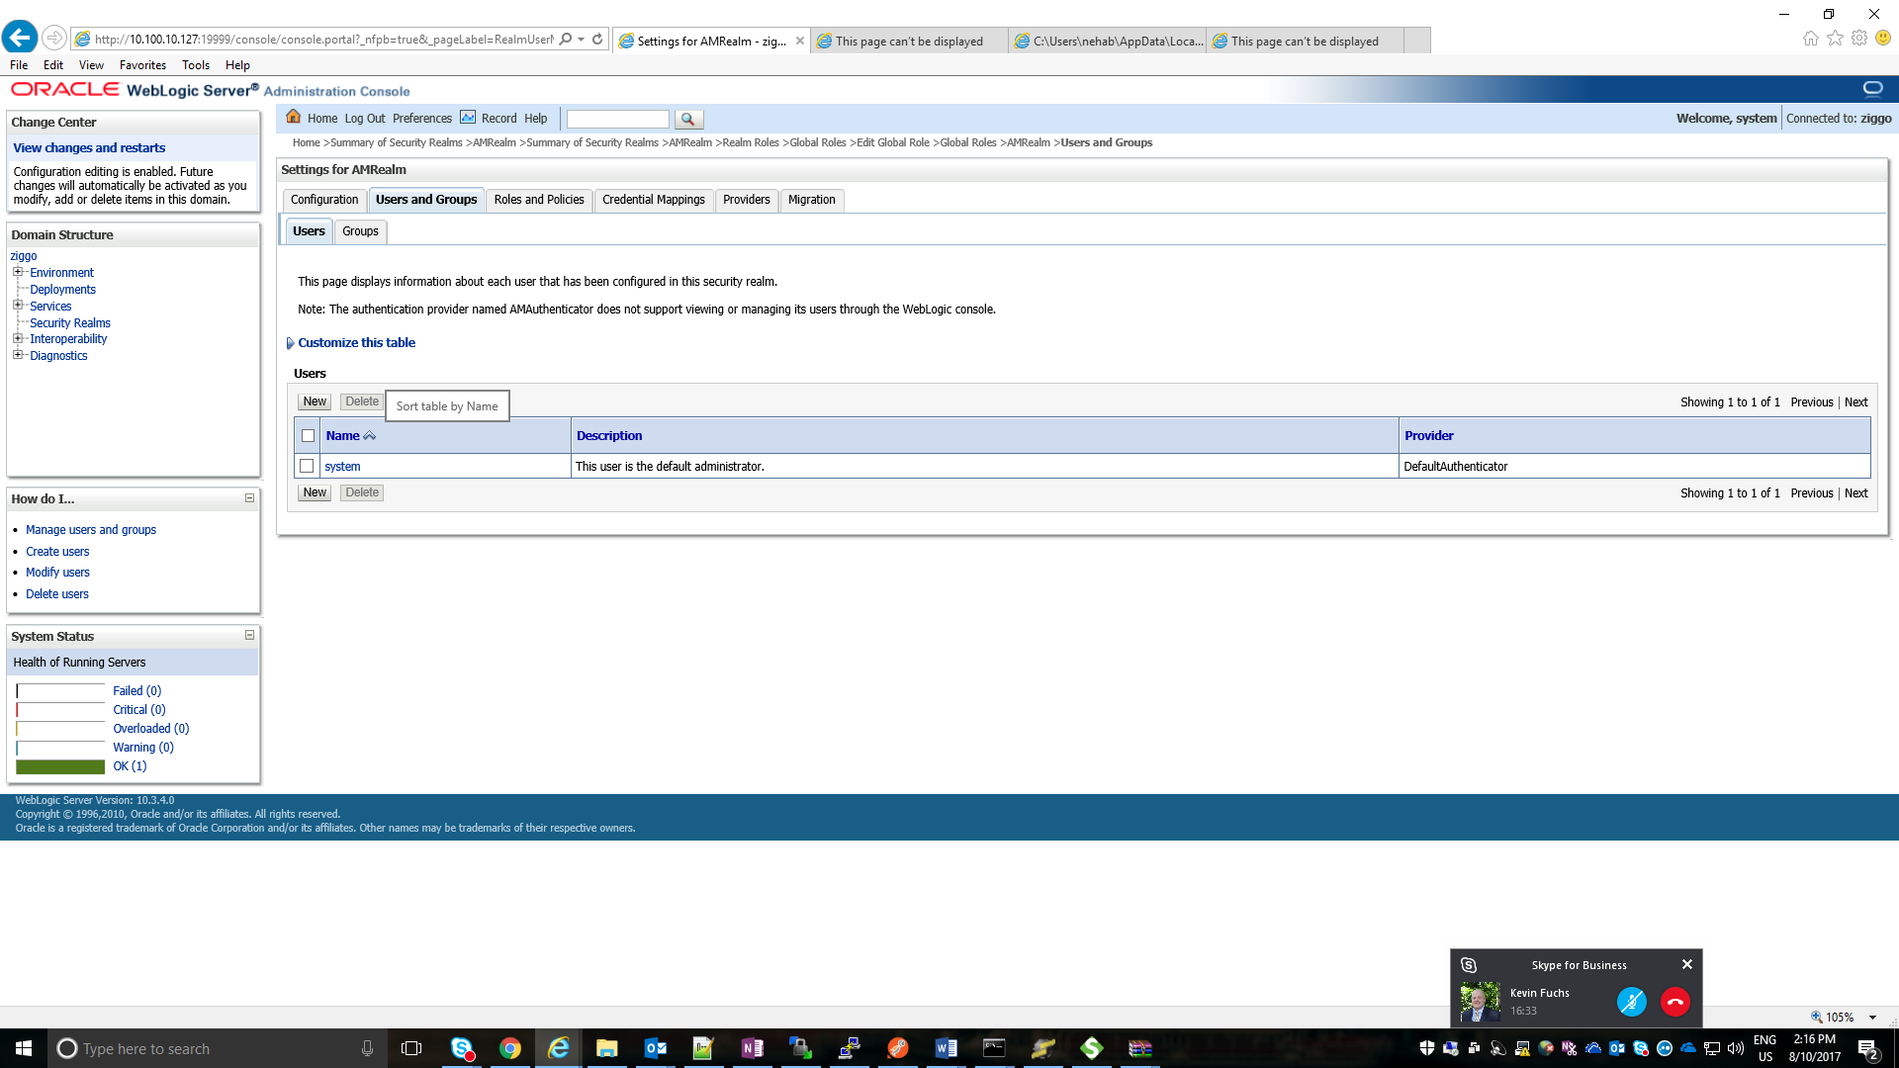

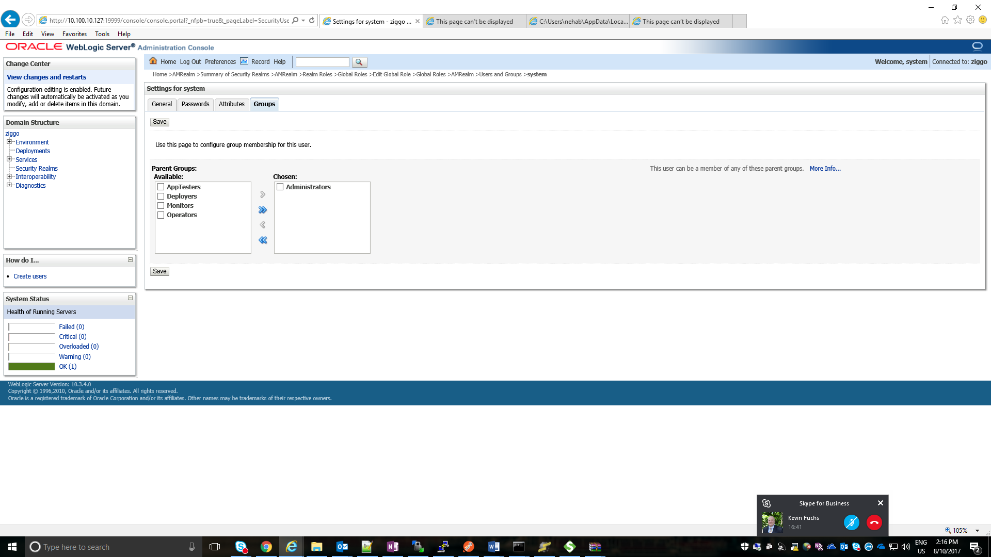

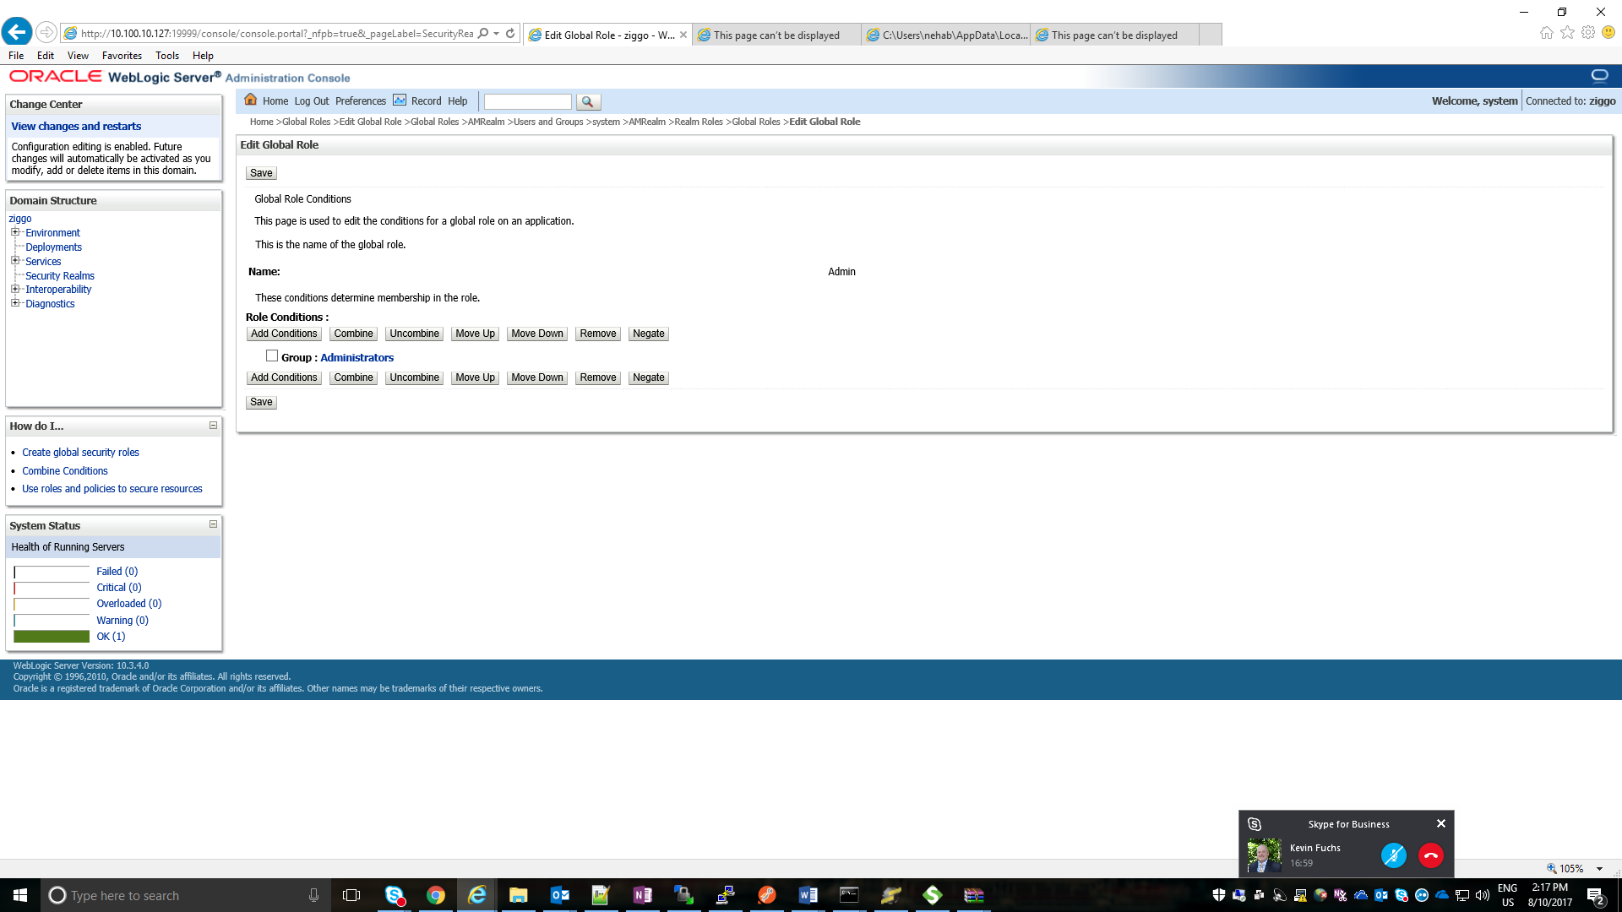

1. Check if you are able to access the WSDL with username and password.

https://{IP:PORT}/LGOSSreply/